GREEN INFRASTRUCTURE STATEMENT & BIODIVERSITY ENHANCEMENT SCHEME | 
  - Part 1 - Guidance and advice for Householder Applications

Green Infrastructure Statement
Planning Policy Wales, Edition 12 (PPW12) requires all developments to be supported by a Green Infrastructure Statement (GIS), also called a Green Infrastructure Assessment. Green Infrastructure includes woodland, hedgerows, grassland, lawn, shrubs and water features such as ponds, rivers and canals etc. A GIS demonstrates how the proposed development has firstly tried to avoid any impacts, then describe what has been done to minimise any unavoidable impacts then what measures will be provided to compensate for any losses. This information must be provided before the application is determined and is considered as part of the planning application process.

Biodiversity Enhancements
The Environment (Wales) Act 2016 and Planning Policy Wales require all developments to show no net loss to biodiversity, (also known as biodiversity enhancement). This can be achieved by including biodiversity enhancement measures in your development. These don’t need to be costly or large in scale and should be proportionate to the development. A net benefit can only be achieved after avoiding damage, minimizing (mitigation) impacts and providing enough compensation (replacement). The enhancements do not need to be directly attached to the proposed new construction; they can be attached to the original dwelling or placed within the garden, but they should be within the red line boundary of your application.

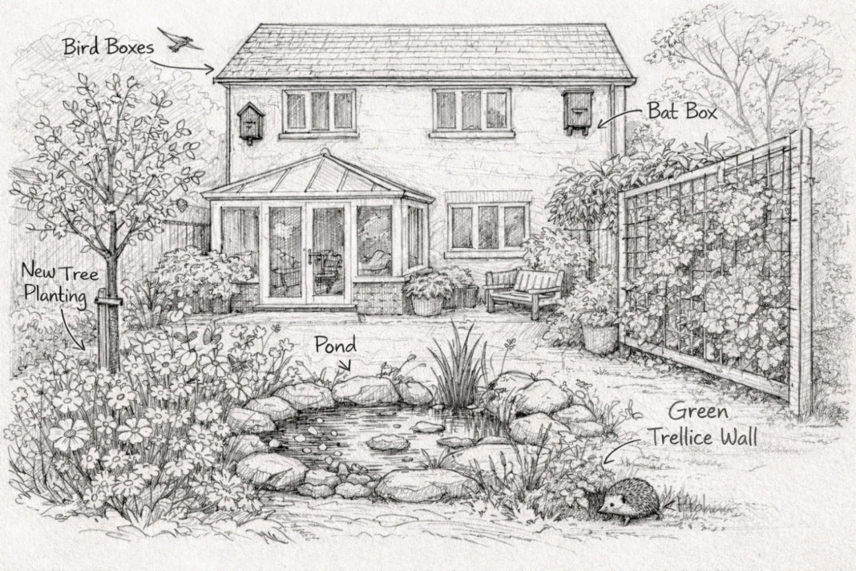

New Shrubs

Wildflower planting
Below are examples of biodiversity enhancements which are applicable to householder applications, however we will consider any other options submitted.

Preferred option for all developments – integrated bird box
Woodstone® Build-in Swift Nest Box | Vivara Pro WoodStone® Build-in Open Nest Box | Type 24 Schwegler Brick Nest Box
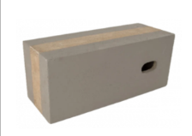 | 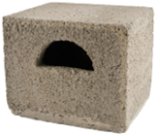 | 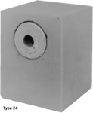

Other - Suitable for most householder developments
Vivara Pro Seville 32mm WoodStone® Nest Box / Vivara Pro Seville 28mm WoodStone® Nest Box | 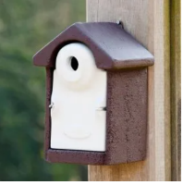 | 1B Schwegler Nest Box | 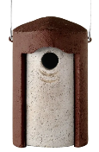
Vivara Pro WoodStone® Starling Nest Box | 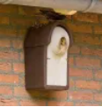 | Vivara Pro WoodStone® House Sparrow Nest Box | 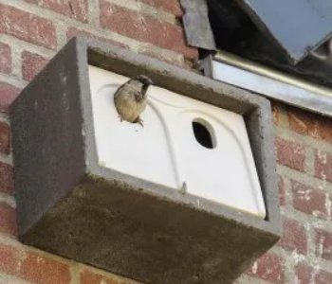
1SP Schwegler Sparrow Terrace | 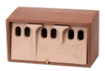 | 2H Schwegler Robin Box | 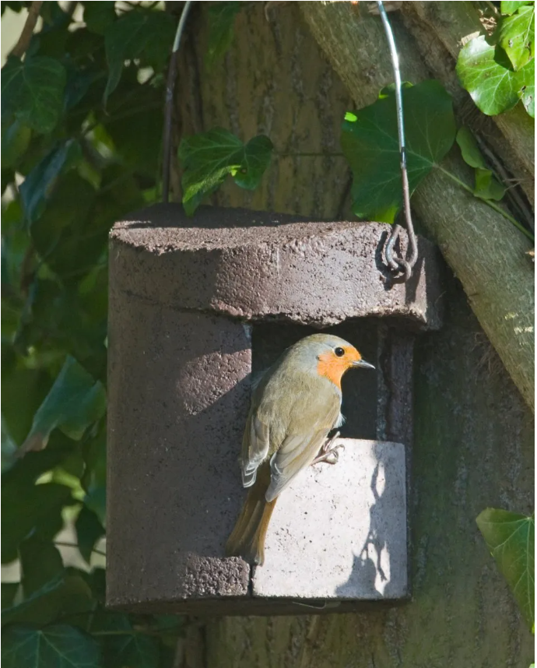
Vivara Pro Barcelona WoodStone® Open Nest Box | 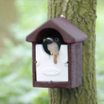 | 2MR Schwegler Open-Fronted Avianex | 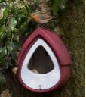
Hedgehog nest box  *also need hedgehog access into garden. | 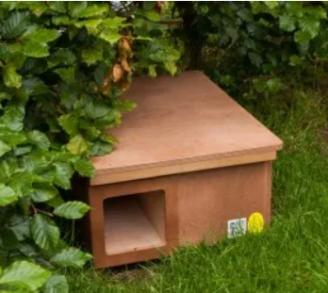 | Bug hotel | 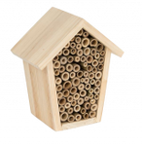
Vivara Pro Woodstone House Martin Nest | 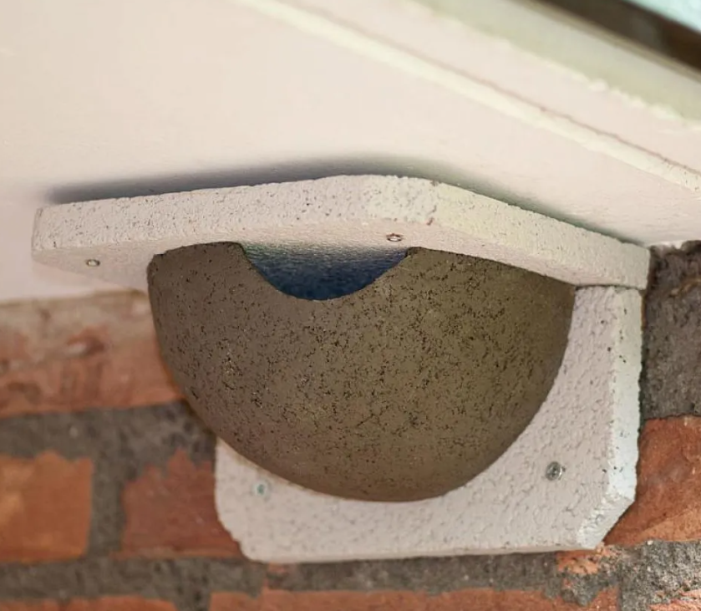 | 9A Schwegler House Martin Nest | 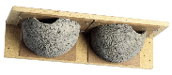
Lavender bush
Wildflower planting |  | Minimum area 1m²
Rural sites - Nest cups suitable for Swallows. Must be sited under cover, eg under a eaves overhang or in an open barn or stable. At least 2m above the ground. Swallow nest cups particularly useful for barn conversions and new stables.
WoodStone® Swallow Nest Bowl (Plywood board mounted) | 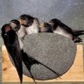 | No. 10B Schwegler Swallow Nest | 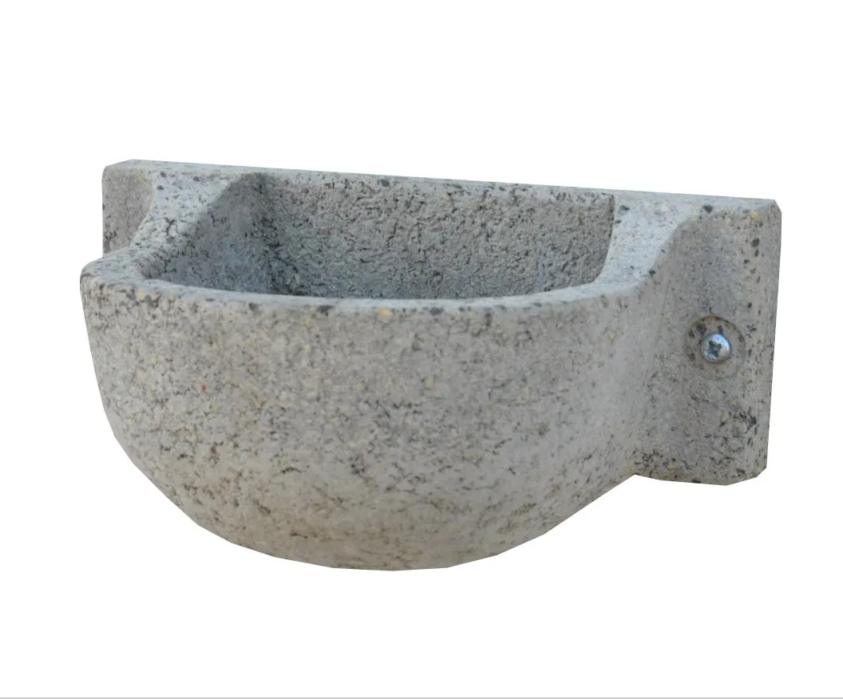

Larger sites
Barn Owl Nest Box | Tawny Owl Nest Box | Woodpecker Bird House |  | Kestrel Nest Box | Treecreeper Nest Box
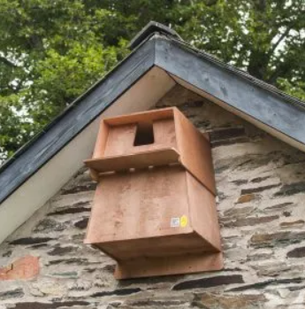 | 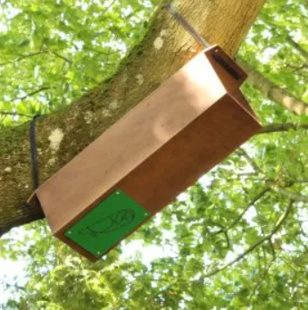 | 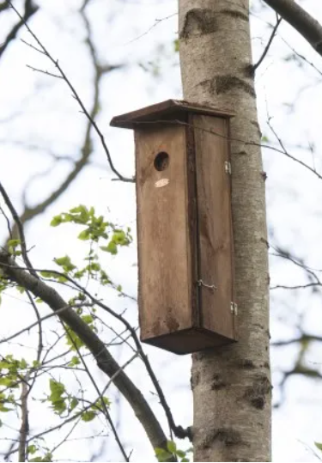 |  | 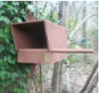 | 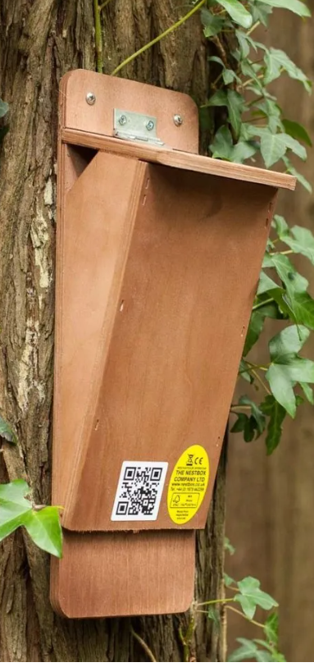
Tree |  |  | Native species required
Wildlife pond |  |  | Must have an escape ramp and NO FISH
Native hedgerow

How do I provide the information?
Any biodiversity enhancements to be provided must also be shown on other plans submitted, for example elevations plans or boundary treatments plans.

The first part of this form is advice and information only, and the second part will need to be completed and returned to your Planning Officer.

Handy advice
- Bird boxes must be only wood or “woodcrete”. Avoid metal or ceramics. Avoid bird boxes with perches.
- Swift boxes need to be very high up – at the gable apex of a standard 2-storey house is the minimum height, preferably at 3rd storey level or higher and placed in groups
- Cleaning the box can be done between November and February – remove and dispose of all the old nesting material including any unhatched eggs. If necessary, rinse out box with boiling water only, and allow to dry naturally. Place lid back on box. (Note bat boxes do not require cleaning)
- When considering where to put a bird box, you may want to avoid putting them above patio’s, seating areas and windows/doors.
- For Hedgehog boxes, use only wooden boxes and avoid woven boxes. Hedgehog access into the garden will also be needed. If no natural access exists, a hole of a 130mm x 130mm at ground level will need to be created by cutting a hole in a fence.

Useful links
The website links below will take you to sites such as the Wildlife Trusts, Woodland Trust and RSPB, all of which have useful information.

- Wildlife trusts – Pond advice
- RHS Plants for Pollinators / RHS
- All about wildlife-friendly plants
- How to make a shrub garden for wildlife | The Wildlife Trusts
- How to Attract Wildlife to Your Garden - Woodland Trust
- Buying a nest box | BTO - British Trust for Ornithology

Some suppliers
Boxes and other equipment for wildlife can be purchased at many different sites, below are a few suppliers. We do not recommend any specific supplier and other retailers are available.

- NHBS - Wildlife, Ecology & Conservation
- Bird Houses & Nesting Boxes for Wild Birds - RSPB Shop
- Bird Nest Boxes | The Wildlife Community
- Bird Boxes & Nesting Boxes - Garden Wildlife Direct
- Bird Boxes | Specialist Nest Boxes for UK species | The Nestbox Company Limited

Thankyou to Unitura, Vivara Pro, Habibat, Schwegler and NHBS for permission to use their photographs

