
83 Burdons Close, Wenvoe, CF5 6FE Low Cost Home Ownership

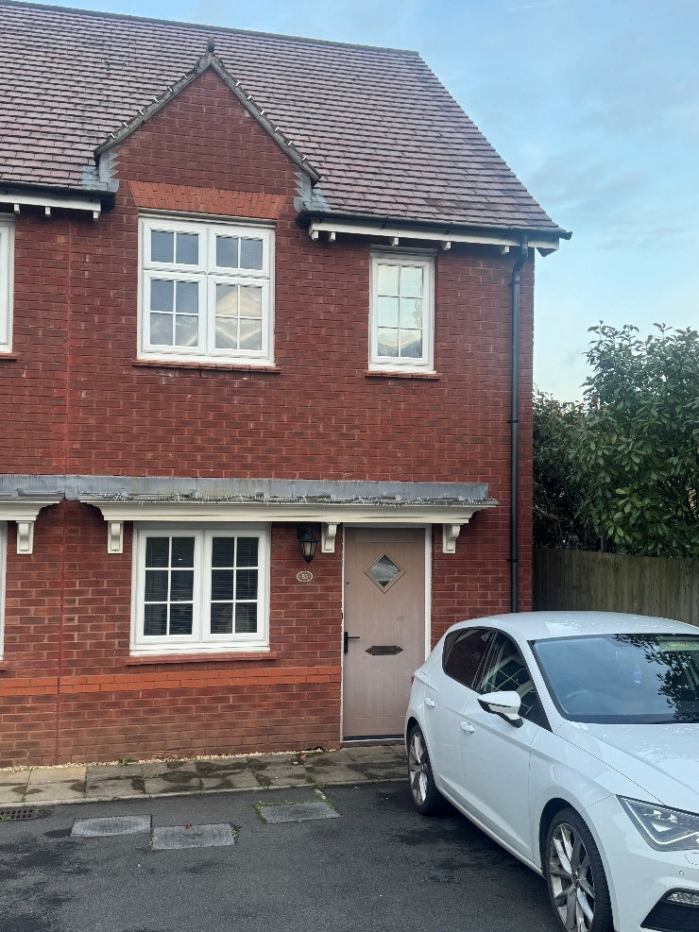
£189,000 (70%)
£270,000 (100%)
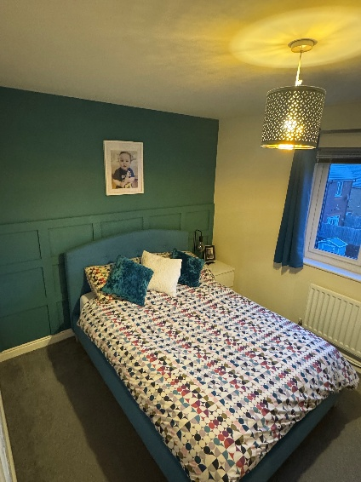
- EPC Rating B
- Shared Equity Purchase
- Two Bedrooms
- Downstairs WC
- Redrow Development


1
2
1




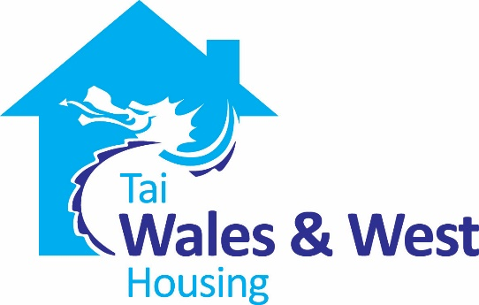
Applicants interested in purchasing this superb home will need to register their interest through Aspire 2 Own.

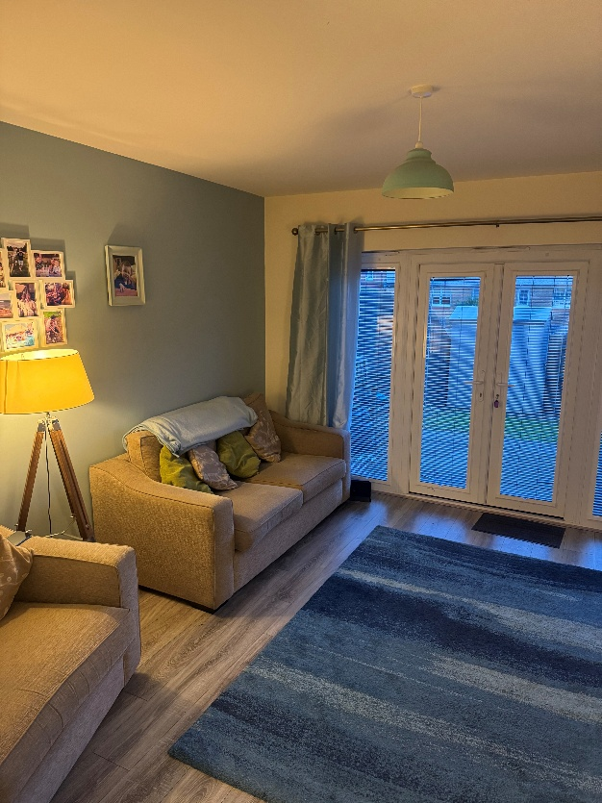
About the property
Wales & West, in partnership with Aspire 2 Own, are pleased to offer this well presented, two bedroom end of terrace home in the popular location of Wenvoe, ideally located for access links to Cardiff and M4. The property benefits from two good sized bedrooms, an open living space to the ground floor with doors leading to the garden and a downstairs WC. This lovely starter home has off road parking and rear access and offers a fantastic opportunity to get onto the property ladder.

To be eligible for the scheme, applicants must:
- Be over the age of 18
- Be a UK or EU/EEA passport Holder or have Indefinite Leave to Remain in the UK
- Be able to raise a mortgage and be able to afford the financial costs of purchasing a property, including the deposit required by the lender
- Use the property as their main residence
- Either be living or working in the Vale of Glamorgan or for those leaving the Armed Forces to have lived in the Vale of Glamorgan for 6 months prior to joining.

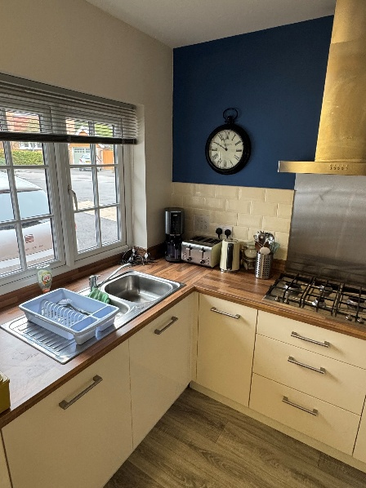
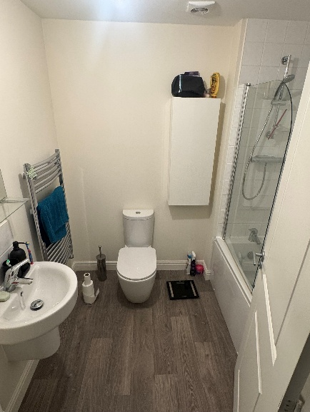
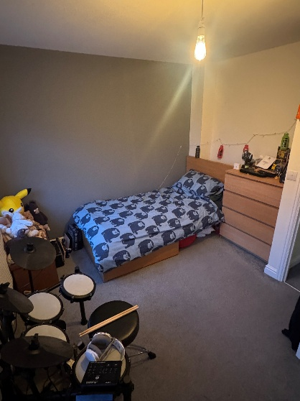
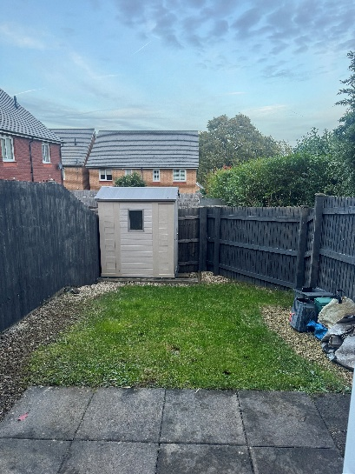

Interested?

To register your interest, or for further information on the scheme, either contact;

Aspire 2 Own (Vale of Glamorgan’s affordable housing)
Telephone: 01446 709476 or 01446 709433 Email: housingstrategy@valeofglamorgan.gov.uk

Or
Bethan Christofides
Residential Sales Officer at Wales & West Housing
Telephone: 07790396683 Email: beth.christofides@wwha.co.uk

Contact the Aspire 2 Own team to arrange a viewing/ complete an application form.
You will find more information on Low Cost Home Ownership on our website https://www.wwha.co.uk/en/find-a-home/

